

**Pt. Deen Dayal Upadhyay Management College, Meerut**

**Minor Project Report**

**On**

**( Hotel Management System )**

**BCA - 507**

**Session 2022 - 25**

**Submitted To: Submitted By:**

**Mr. Vimal Prasad Nitin Saxena**

**220973106186**

**CREATIVE TECHNOLOGIES**

**CERTIFICATE OF MERIT**

**Summer Training & Internship Program 2024**

This is to certify that Mr.Nitin Saxena student of BCA 3rd Yr has undergone **5 weeks** of online training in **Core Java Programming** from **10th July, 2024 to 23rd August, 2024** conducted at **Pt. Deen Dayal Upadhyay Management College, Meerut** during *Summer & Project Training Program* conducted by *Creative Technologies Pvt. Ltd.*

For Pt. DDUMC, Meerut

**Dr. Robins Rastogi**

**( HOD | BCA )**

INDEX

Table of Contents

1. **ACKNOWLEDGMENT4**
2. **ABSTRACT5**
3. **INTRODUCTION OF PROJECT6**
4. **MODULE7-8**

**~VISION STATEMENT8**

1. **OBJECTIVE OF PROJECT9-10**

**~THE OBJECTIVE AND SCOPE OF HOTEL MANAGEMENT SYSTEM10**

1. **FEATURES/ FUNCTIONALITY11**
2. **USE CASES SUMMARY12**
3. **SOFTWARE AND HARDWARE REQUIREMENT 13**
4. **DEVELOPMENT TOOLS AND TECHNOLOGIES14**
5. **USER INTERFACES AND DESIGN15-20**

**~USER LOGIN INTERFACE15**

**~USER REGISTRATION INTERFACES16**

**~DASHBOARD INTERFACES17**

**~BOOKING ROOM18**

**~ROOM INFORMATION19**

**~CUSTOMER MANAGEMENT INTERFACE20**

**11.CONCLUSION21**

**12. LIMITATIONS AND FUTURE WORKS22**

**13.BIBLIOGRAPHY AND REFERENCES23**

**ACKNOWLEDGMENT**

**Praise and thanks to Almighty God for the success of this project work. It is essential at this point to acknowledge with thanks those who have made useful contributions to facilitate the successful accomplishment of this academic task.**

**We wish to express or reserved gratitude to our supervisor, MR. VIMAL PRASAD for his comments and suggestions for expanding of knowledge on this our research work. Our deepest appreciation goes to our friends and course mates and everyone who helped us throughout the course of writing this project.**

**Finally, while we acknowledge the contribution of all, we claim total responsibility for whatever shortcomings the project may have or contain. Perfection belongs only to Almighty God.**

**~ Nitin Saxena**

**220973106186**

**ABSTRACT**

**Hotel Management System is a software system where the management of entire hotel is computerized. The hotel management system is designed using JAVA Swing as the rich GUI for front end and MySQL Server as the secured backend database.**

**In this project the details are maintained like customer details, employee details, booking details and billing details. Booking the rooms, vacating the rooms, the restaurant management, billing process, staff management etc. All is computerized and the management is done without any difficulty.**

**The reports can be viewed completely and the head of the management daily or weekly or monthly can review it. For company auditing it will be more useful. This Proposed System will be interactive, faster and user-friendly for the end users. Using the hotel management system, the following activities can be performed:**

* **Room Service**
* **Check In**
* **Check Out**
* **Food Menu**
* **Staff Master**
* **Restaurant**
* **Login**

**INTRODUCTION OF PROJECT**

**The Hotel Management System is a comprehensive software application designed to streamline the operations of a hotel. It aims to automate various tasks such as booking management, customer check-in and check-out, billing, and reporting. The system is developed using Java, which provides a robust and platform-independent environment for application development.**

**The problems faced by the existing system and hope to be solved by**

**The Hotel Management System are described below:**

* **Difficulty in maintenance of records**
* **Time consuming**
* **Editing of data becomes a tedious job**
* **No security of data**
* **Lack of efficiency**
* **Data redundancy**
* **Data inconsistency**
* **Incidence of Fraud**

**In The Hospitality Industry, Efficient Management of resources and customer satisfaction are paramount. The Hotel Management System addresses these needs by providing a user-friendly interface for both hotel staff and guests. The application allows for real-time updates and management of hotel operations, ensuring that all processes are handled smoothly and efficiently.**

**The system is designed to cater to various functionalities, including room reservation, customer management, billing, and reporting. By automating these processes, the Hotel Management System reduces the chances of human error and enhances the overall efficiency of hotel operations.**

**MODULE**

**1. Check-in and Check-out module:**

**First greet the customer and we take the details of the customer so that we can verify the identity of that customer. Then, we will talk about the room i.e. either you want room for smoking area or not and we will also talk for spend the days. Then we provide the identity card number to you. When you will arrive we will ask your name and the date at which you have registered. We will give you the registration form so we can check you in and show the identity card and then how will you pay the money either by credit card, debit card, cash, etc. then we will provide you the room key. When there is a time to check out then first we will see the room condition and if it is perfect then you can go and get the receipt from the counter. If you have any complain about our hotel then you can say without hesitation we will do our best at next time.**

**2. Restaurant:**

**This is the major facility which we provide to our customers. We have a proper kitchen with adequate staff and we also maintain a menu according to the demands of the customers. We also take further steps for proper hygiene in the kitchen. We also provide telephone facility so that the customers will order the food form their room.**

**3. Staff management:**

**We have created a proper staff as per need in the hotel. And we are selective in hiring our staff. We give them work according to their skills and we communicate with them properly so that they work properly. We also monitor who and when has changed the order status. Our staff uses their time efficiently as modifications of new orders go directly to the right department and everybody knows what to do next. We are in touch with them for their help.**

**4. Admin Login:**

**This aims to create hotel booking online. Customer can check the available rooms and the customer data. The user register and log into system. The administrator knows the details of room. Software is being designed in such a way as they provide all the information to the customers including hotel rooms, specifications, and services provided. By this, it is the advantage for the customer to remove the existing flaws in manual system booking hotel rooms.VISION STATEMENT**

**The project “Hotel Management System” is aimed to develop to maintain the day-to-day state of vacation of residents, List of employees, List of customer, Restaurant etc.**

**There are following main objectives of the hotel:**

* **Records of data, salary etc, structure of the employees of Hotel.**
* **Keeping records of vacation of resident.**
* **Keeping user satisfaction as at most priority.**
* **Scheduling the allotment of user with room to make it convenient for user.**
* **Scheduling the services of manager, employee, workers and driver and properly so that facilities provided by Hotel are fully utilized in effective and efficient manner.**
* **Keeping records of user check-in details accurately arranged order so that the treatment of Customers becomes quick and satisfactory.**
* **Keeping details about the users, their needs.**
* **Keeping the best hotel facilities.**
* **Keeping detail about restaurant.**
* **Maintain administration detail.**

**OBJECTIVE OF PROJECT**

**The primary objectives of the Hotel Management System project are as follows:**

**Automation of Booking Process: To automate the room booking process, allowing customers to make reservations online and reducing the workload on hotel staff.**

**Customer Management: To maintain a database of customers, enabling easy access to customer information and history for better service.**

**Billing and Invoicing: To automate the billing process, ensuring accurate invoicing and payment processing for customers.**

**Reporting: To generate various reports, such as occupancy rates, revenue reports, and customer feedback, to assist management in decision-making.**

**User -Friendly Interface: To provide an intuitive and easy-to-navigate interface for both hotel staff and customers, enhancing user experience.**

**Data Security: To ensure that all customer data is securely stored and protected from unauthorized access.**

**Scalability: To design the system in a way that allows for future enhancements and scalability as the hotel grows.**

**The Objective and Scope of Hotel Management System is as follow:**

* **Front-desk operations (customer management, room allocation, employee management).**
* **Accommodation (Hotel room management, staff schedules, inventory).**
* **Staff record Management.**
* **Available room record.**
* **Booked room record.**
* **Check-in and check-out.**
* **Customer record management.**
* **Restaurant veg & non-veg food operation.**
* **Staff scheduling.**
* **Admin login.**
* **Hotel Management System takes the following into consideration:**
* **The system must make the hotel services fully known to the customer such as the room details and pricing.**
* **The system must be able to search databases or records to provide quick result based on users query.**
* **The system should ensure data consistency and no duplication of data no matter how small.**
* **The system must be accessed only by authorized persons.**
* **The design (Graphical) must be comprehendible and not clumsy to the admin, easy to use, and easy to understand.**
* **The system must have access levels based on user roles such as Manager-Administrator-Accountant-Other staff.**
* **The system must carry out only actions specified by the user (browse, modify, delete, add).**

**FEATURES AND FUNCTIONALITY**

**The features or functionality of Hotel Management System is as follows:**

1. **Dashboard**
2. **Check In/Check-out Module**
3. **Available and Non-Available Room Module**
4. **Customer Details**
5. **Staff Details**
6. **Staff Scheduling**
7. **Restaurant Veg & Non-Veg Meal**
8. **Admin Login**

**USE CASES SUMMARY**

**1. Check-in and Check-out module:**

**First greet the customer and we take the details of the customer so that we can verify the identity of that customer. Then, we will talk about the room i.e. either you want room for smoking area or not and we will also talk for spend the days. Then we provide the identity card number to you. When you will arrive we will ask your name and the date at which you have registered. We will give you the registration form so we can check you in and show the identity card and then how will you pay the money either by credit card, debit card, cash, etc. then we will provide you the room key.**

**When there is a time to check out then first we will see the room condition and if it is perfect then you can go and get the receipt from the counter. If you have any complain about our hotel then you can say without hesitation we will do our best at next time.**

**2. Restaurant:**

**This is the major facility which we provide to our customers. We have a proper kitchen with adequate staff and we also maintain a menu according to the demands of the customers. We also take further steps for proper hygiene in the kitchen. We also provide telephone facility so that the customers will order the food form their room.**

**3. Staff management:**

**We have created a proper staff as per need in the hotel. And we are selective in hiring our staff. We give them work according to their skills and we communicate with them properly so that they work properly. We also monitor who and when has changed the order status. Our staff uses their time efficiently as modifications of new orders go directly to the right department and everybody knows what to do next. We are in touch with them for their help.**

**4. Admin Login:**

**This aims to create hotel booking online. Customer can check the available rooms and the customer data. The user register and log into system. The administrator knows the details of room.**

**Software is being designed in such a way as they provide all the information to the customers including hotel rooms, specifications, and services provided. By this, it is the advantage for the customer to remove the existing flaws in manual system booking hotel rooms.**

**SOFTWARE AND HARDWARE REQUIREMENT**

**Software Requirements:**

**1. Operating System : Windows 7 and upwards operating**

**system**

**2. JDK : Java SE Development Kit 11**

**3. Integrated Development**

**Environment (IDE) : Eclipse / Net Beans**

**4. Database : MySQL 8.0.17**

**Hardware Requirements:**

**5. Processor : Dual core Intel**

**6. Clock Speed : 2 GHz**

**7. Storage : 750 MB free disk space**

**8. RAM : 1GB or more**

**9. Keyboard : 101 Keys**

**10. Mouse : Optical Mouse**

**DEVELOPMENT TOOLS AND TECHNOLOGIES**

**Front End –**

**Java Swing - Java Swing is a lightweight Java graphical user interface (GUI) widget toolkit that includes a rich set of widgets. It is part of the Java Foundation Classes (JFC) and includes several packages for developing rich desktop applications in Java. Swing includes built-in controls such as trees, image buttons, tabbed panes, sliders, toolbars, color choosers, tables, and text areas to display HTTP or rich text format (RTF). Swing components are written entirely in Java and thus are platform-independent.**

**Back End –**

**MySQL - MySQL is a database management system. It may be anything from a simple shopping list to a picture gallery or the vast amounts of information in a corporate network. To add, access, and process data stored in a computer database, you need a database management system such as MySQL Server.**

**Java - Java is a high-level programming language developed by Sun Microsystems. It was originally designed for developing programs for set-top boxes and handheld devices, but later became a popular choice for creating web applications.**

**Development Environment –**

**NetBeans - NetBeans IDE lets you quickly and easily develop Java desktop, mobile, and web applications, as well as HTML5 applications with HTML, JavaScript, and CSS. The IDE also provides a great set of tools for PHP and C/C++ developers.**

**Visual Design –**

**Adobe Photoshop - Adobe Photoshop is the predominant photo editing and manipulation software on the market. Its uses range from the full-featured editing of large batches of photos to creating intricate digital paintings and drawings that mimic those done by hand.**

**USER INTERFACES DESIGN**

**User Login Interface:**

**Description: A secure login page for hotel staff and administrators to access the system.**

**Features: Username and password fields, "Forgot Password" option, and user role selection.**

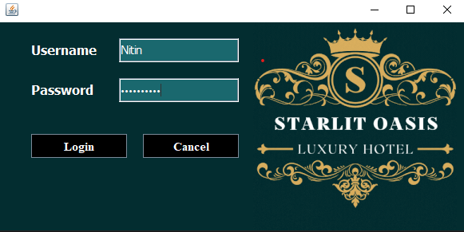

**User Registration Interface:**

**Description: A secure Registration page for Hotel Staff and Administrators to access the system.**

**Features: Username, Email, Phone Number, Gender, Create Password Options, All Employees Info, cutomer Info, Rooms, Department, checkout**

**Update check in details, pickup services, search room, logout, back and user control selection.**

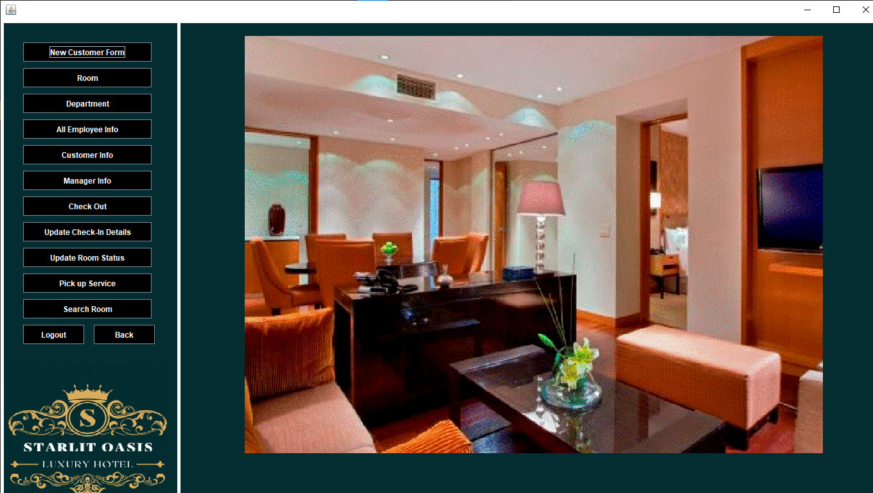

**.**

**Dashboard Interface:**

**Description: A central dashboard displaying key metrics such as occupancy rates, upcoming bookings, Available Rooms, Customer Info, Employee Info, Administrative, Occupied Rooms and revenue.**

**Features: Quick access to various modules, notifications, and alerts**

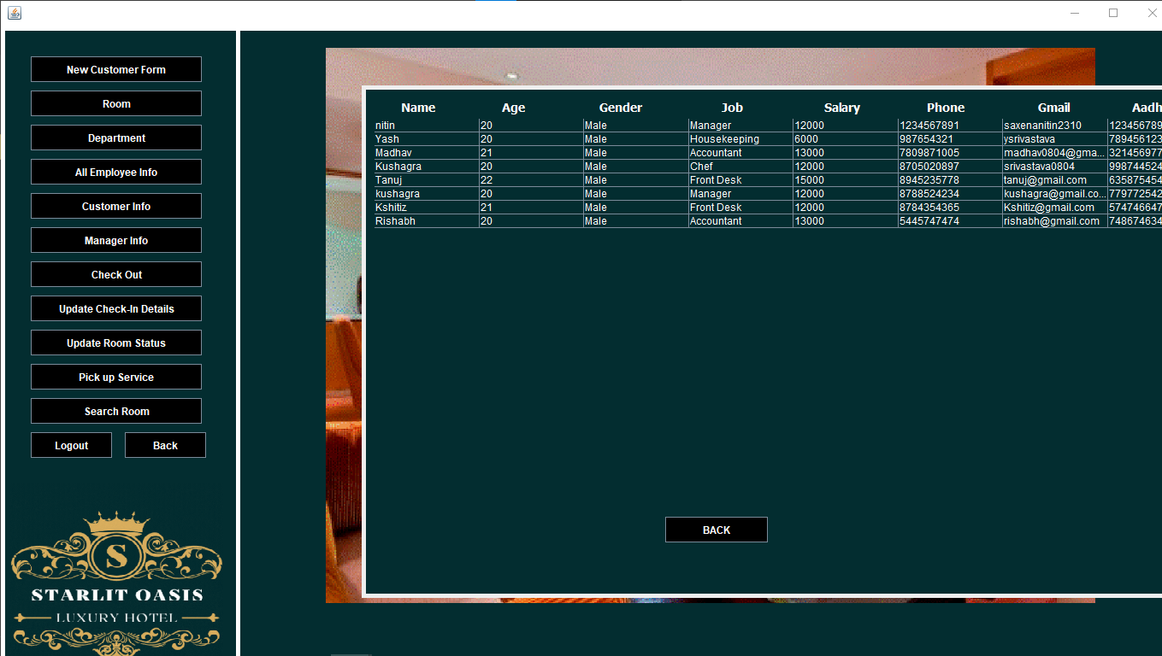

**Booking Room:**

**Description: Our Standard Rooms offers a cozy retreat with comfortable beds, perfect for families or friends traveling together. Enjoy modern amenities and a welcoming atmosphere for a restful stay.**

**Features: Offering Diifferent Types Of Rooms; Luxury, Air Conditioned, Non Air conditioned, And Classic**.

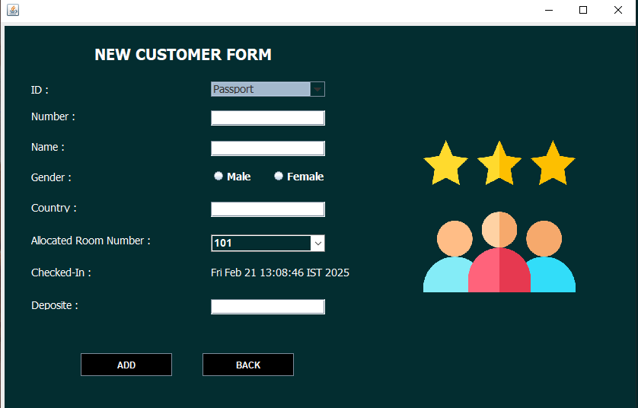

### 

### 

### 

### **Room Info:**

### **Description: The Executive Suite offers a blend of luxury, Comfort, Affordable perfect for both business and leisure travelers. This spacious suite features a separate living area and a bedroom with a king-sized bed adorned with premium linens. Large windows provide ample natural light and stunning views of the surrounding area. The modern decor and thoughtful amenities create an inviting atmosphere for relaxation or productivity**

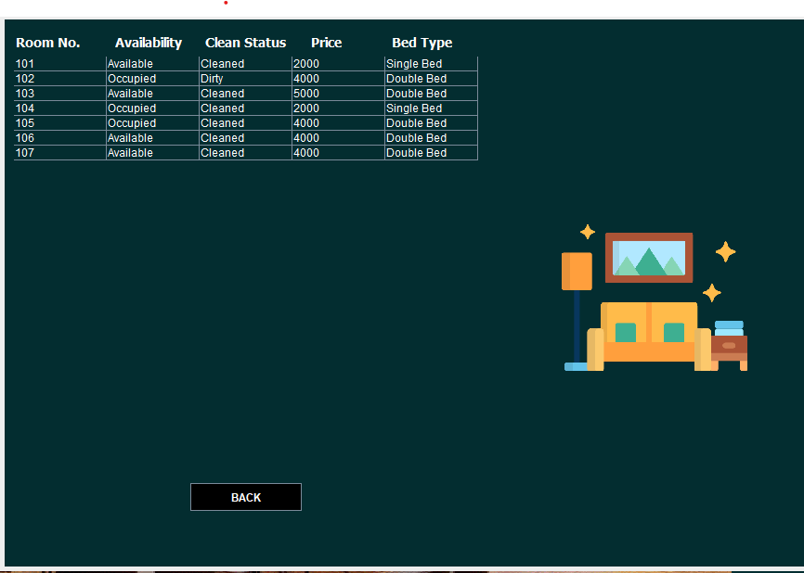

### 

### 

### **Customer Management Interface:**

### **Description: An interface for hotel staff to manage customer information and history.**

**Features: Add, edit, and delete customer records, view booking history, and search functionality.**

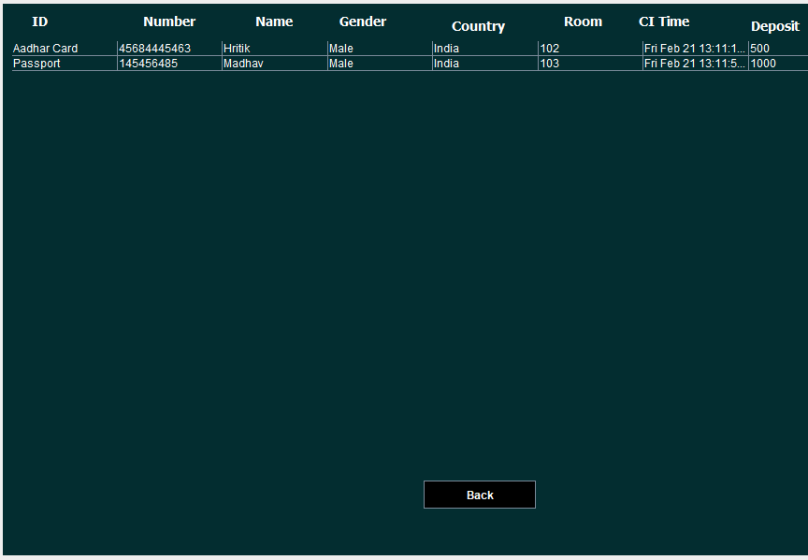

**CONCLUSION**

**The conclusion of this project is A Hotel management system is a computerized management system. This system keeps the records of hardware assets besides software of this organization. The proposed system will keep a track of Workers, Residents, Accounts and generation of report regarding the present status. This project has GUI based software that will help in storing, updating and retrieving the information through various user-friendly menu-driven modules. The project “Hotel Management System” is aimed to develop to maintain the day-to-day state of admission/Vacation of Residents, List of Workers etc. Main objective of this project is to provide solution for hotel to manage most there work using computerized process. This software application will help admin to handle customer information, room allocation details, payment details, billing information etc. Detailed explanation about modules and design are provided in project documentation. The existing system is a manually maintained system. All the Hotel records are to be maintained for the details of each customer, Fee details, Room Allocation, Attendance etc. All these details are entered and retrieved manually, because of this there are many disadvantages like Time Consuming, updating process, inaccuracy of data. For avoiding this we introduced or proposed a new system in proposed system the computerized version of the existing system. Provides easy and quick access over the data.**

**LIMITATIONS AND FUTURE WORKS**

**As earlier mentioned the project study covers Reception, accommodation, finance and account, catering, food ordering, administrative, security, and general services transactions in the Hotel management.**

**However the project has limitations based on these facts**

**The “finance and account” aspect of the HMIS will not capture the budget function; it only captures the accounts receivables and accounts payable.**

**Another limitation of the system is that customer’s signature will not be captured. This process might make procedures cumbersome, which is what the study hopes to eliminate; however it captures full details of the customer.**

**The system does not have an online payment option on the online room reservation menu.**

**The system is not designed to run on-line.**

**Due to time constraints certain fields were not included; the software was therefore reduced to covering critical aspect of hotel management.**

**These limitations were encountered in the course of the study, and appropriate techniques have been applied to ensure the system functions properly thereby eliminates the “stale mate”.**

**BIBLIOGRAPHY / REFERENCES**

**Java Documentation - Get Started (oracle.com)**

**Java Tutorial | Learn Java - javapoint**

**Java Tutorial (w3schools.com)**

**SQL Tutorial - Tutorialspoint**

**Stack Overflow - Where Developers Learn, Share, & Build Careers**

**YouTube**

**Herbert Schildt “Java: The Complete Reference” Tata McGraw-Hill Publishing Company Limited, Seventh Edition**